Criando o ambiente virtual e instalação do Django

File > New Project >

Location: D:\Google Drive\PYTHON\djo1

New Virtual environment > Using Virtualenv

Location: D:\Google Drive\PYTHON\djo1\env

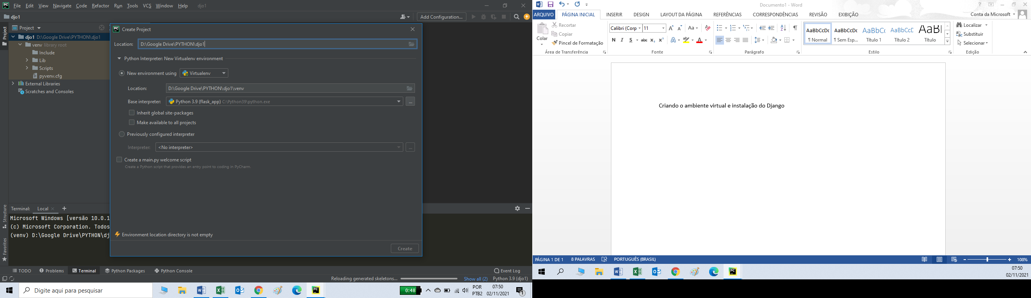

No terminal:

**pip install django**

Microsoft Windows [versão 10.0.19042.1288]

(c) Microsoft Corporation. Todos os direitos reservados.

(venv) D:\Google Drive\PYTHON\djo1>**pip install django**

Collecting django

Downloading Django-3.2.9-py3-none-any.whl (7.9 MB)

|████████████████████████████████| 7.9 MB 1.7 MB/s

Collecting sqlparse>=0.2.2

Using cached sqlparse-0.4.2-py3-none-any.whl (42 kB)

Collecting pytz

Using cached pytz-2021.3-py2.py3-none-any.whl (503 kB)

Collecting asgiref<4,>=3.3.2

Using cached asgiref-3.4.1-py3-none-any.whl (25 kB)

Installing collected packages: sqlparse, pytz, asgiref, django

Successfully installed asgiref-3.4.1 django-3.2.9 pytz-2021.3 sqlparse-0.4.2

Criar o arquivo com as bibliotecas instaladas no app:

pip freeze > requirments.txt

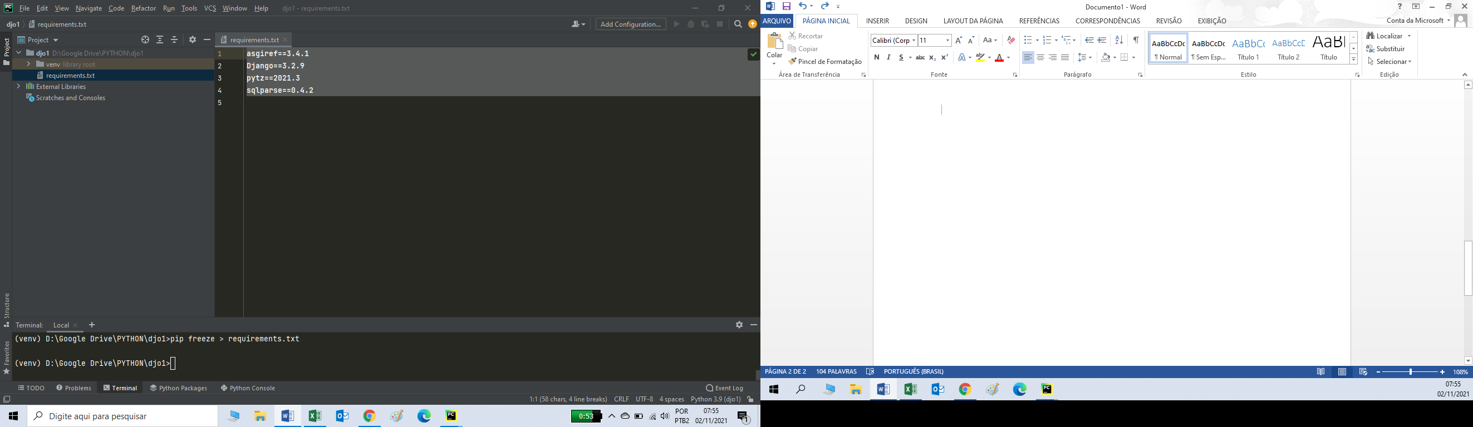

Criar o projeto:

(venv) D:\Google Drive\PYTHON\djo1>django-admin startproject djo1 .

Criar o app: core

(venv) D:\Google Drive\PYTHON\djo1>django-admin startapp core

Arquivo: Settings.py

# SECURITY WARNING: don't run with debug turned on in production!  
DEBUG = *True*

# Application definition  
  
INSTALLED_APPS = [  
 'django.contrib.admin',  
 'django.contrib.auth',  
 'django.contrib.contenttypes',  
 'django.contrib.sessions',  
 'django.contrib.messages',  
 'django.contrib.staticfiles',  
 'core',  
]

TEMPLATES = [  
 {  
 'BACKEND': 'django.template.backends.django.DjangoTemplates',  
 'DIRS': ['templates'],

Criar o diretório ‘templates’ na aplicação:

